SEC815 – Incident Response and Computer Forensics
Project Title:
Memory Forensics Investigation of Credential-Theft Activity
Using Controlled Attack Simulation and Volatile Memory Analysis

PHASE 1 REPORT
Environment Setup, Lab Preparation & Pre-Attack Configuration

1. Introduction
This project simulates a real-world credential-theft attack followed by a full memory-forensics investigation. To accomplish this, a controlled and isolated virtual environment was created using VMware Workstation Pro. The environment consists of two virtual machines: a Kali Linux machine operating as the attacker and forensic analyst workstation, and a Windows 10 system acting as the victim endpoint.
Phase 1 focuses solely on designing and preparing this lab environment. This includes operating system installation, security configuration, tool deployment, network validation, isolation enforcement, and snapshot creation. The goal of Phase 1 is to build a clean, stable, and repeatable foundation prior to executing any attack in Phase 2.
Each configuration step was performed intentionally to emulate realistic adversarial conditions while maintaining complete containment. All screenshots captured during the process are referenced throughout this report to document system state, configuration integrity, and procedural evidence.

2. Scope of Phase 1
The scope of Phase 1 centers on the creation, configuration, and validation of the virtual environment. This includes:
- Deployment of Kali Linux and Windows 10 virtual machines
- Installation of all forensic and offensive tools
- Preparation of directory structures and tool environments
- Adjusting Windows security settings for controlled attack simulation
- Creating a stable forensic workstation on Kali Linux
- Validating network communication between machines
- Enforcing host-only isolation to prevent external exposure
- Taking baseline and pre-attack snapshots
Phase 1 does not execute the attack itself. No payloads are run, no memory is captured, and no forensic analysis is started. Those actions take place in Phase 2 and Phase 3.

3. Tools and Technologies Used
Multiple categories of tools were required for this environment:
Operating Systems
- Kali Linux (Attacker + Forensic workstation)
- Windows 10 64-bit (Victim endpoint)
Virtualization
- VMware Workstation Pro to host isolated VMs
Offensive / Attack Tools
- Mimikatz (credential dumping simulation)
- Python HTTP server for payload delivery
Memory Acquisition Tools
- DumpIt (Magnet Forensics) for full RAM capture
Forensic Analysis Tools
- Volatility 3 (installed in a Python virtual environment)
Networking Tools
- curl
- wget
- netcat
- net-tools
Each tool is referenced within the procedural sections to show when, where, and why it was used.

4. Lab Architecture & Workflow
4.1 Virtual Architecture Overview
The environment is built on a single physical host running VMware Workstation Pro. Two virtual machines operate within this isolated environment: Kali Linux and Windows 10. Both systems are connected through a VMware Host-Only Network using the subnet 192.168.72.0/24, ensuring that they communicate only with each other and remain fully offline during the attack simulation.
The Kali Linux machine serves as:
- The attacker system, hosting payloads via an HTTP server
- The forensic workstation, running Volatility and storing memory dumps
The Windows 10 machine serves as:
- The victim system, where Mimikatz will be executed
- The system from which a full RAM dump will be collected
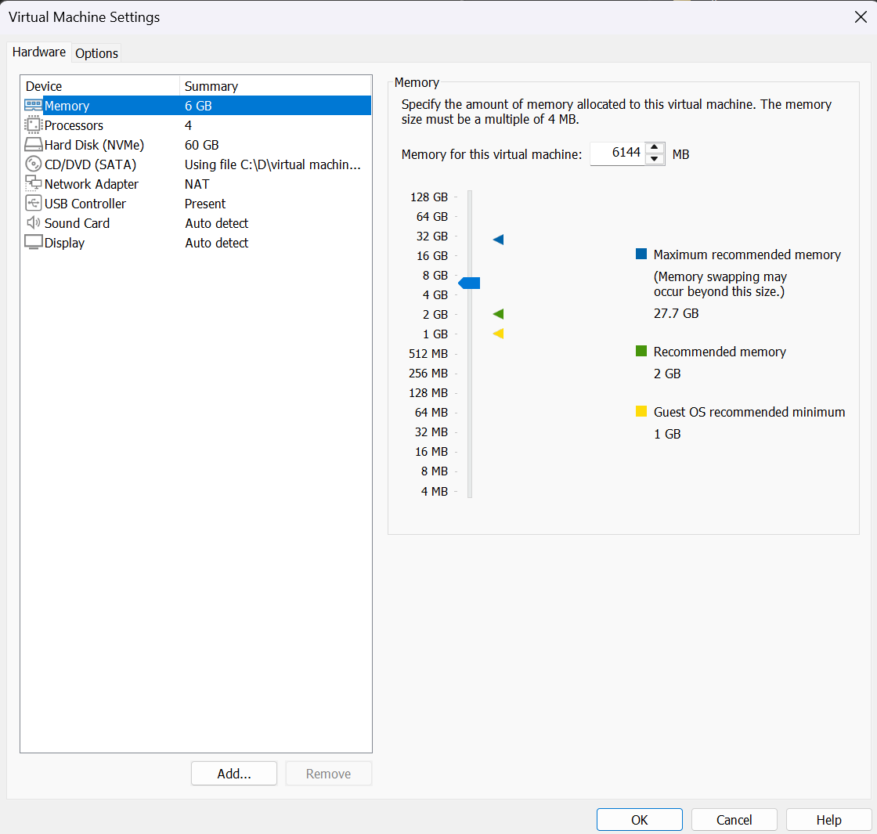
VMware configuration panel showing Kali VM resource allocation and boot settings.
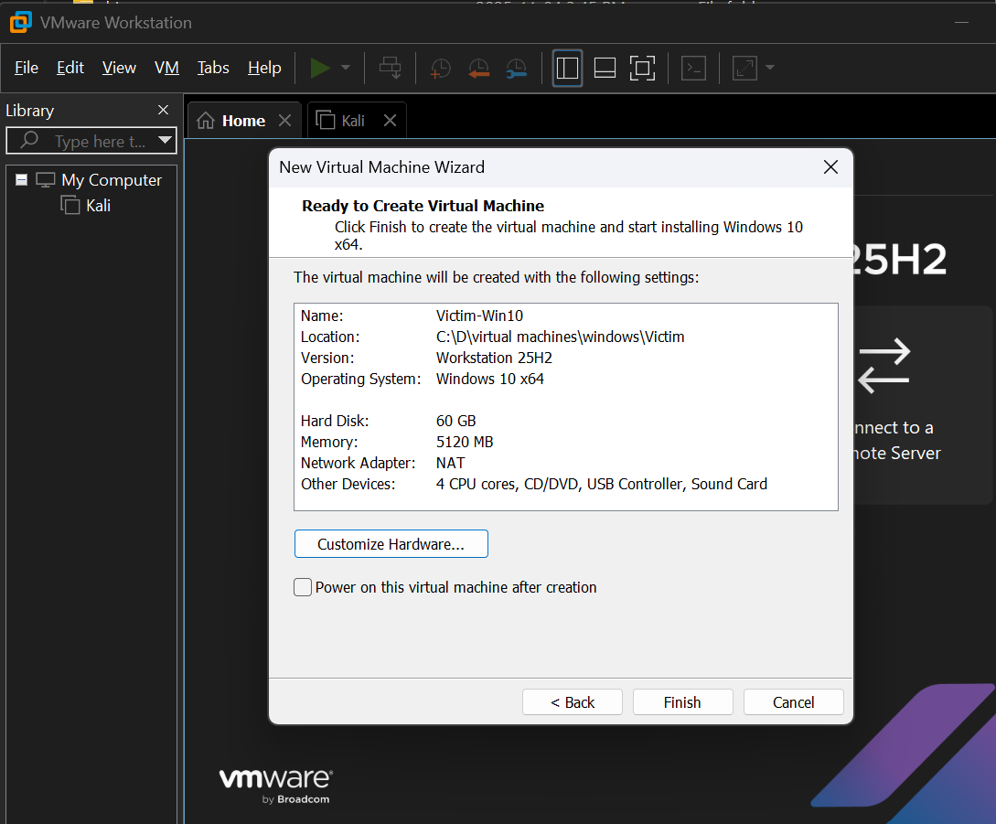
VMware configuration panel for the Windows 10 VM.
4.2 Project Workflow Summary
The entire project follows a structured, IR-aligned flow. Phase 1 prepares the environment, Phase 2 executes the attack and captures memory, and Phase 3 conducts full forensic analysis.
Phase 1 – Environment Setup & Pre-Attack Preparation
- VM creation
- OS configuration
- Security modification on Windows
- Tool installation on both machines
- Network verification (NAT → Host-Only)
- Snapshot creation
Phase 2 – Attack & Memory Acquisition
- Payload hosting on Kali
- File transfer to Windows
- Execution of Mimikatz
- RAM acquisition using DumpIt
- Transfer of memory dump back to Kali
Phase 3 – Memory Forensics & Reporting
- Volatility analysis
- Credential artefact extraction
- Suspicious process analysis
- Timeline reconstruction
- IOC development
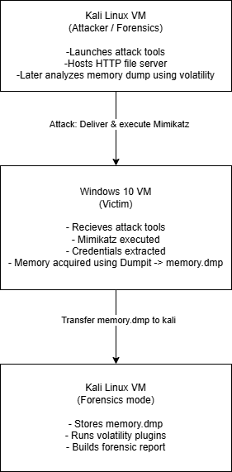

5. Windows 10 Victim System Preparation
5.1 Initial Security Configuration Adjustments
Because Mimikatz and DumpIt are classified as potentially malicious, Windows Defender must be controlled to prevent deletion of tools or blocking execution. Controlled Folder Access, Real-Time Protection, and related features were turned off in a controlled manner.
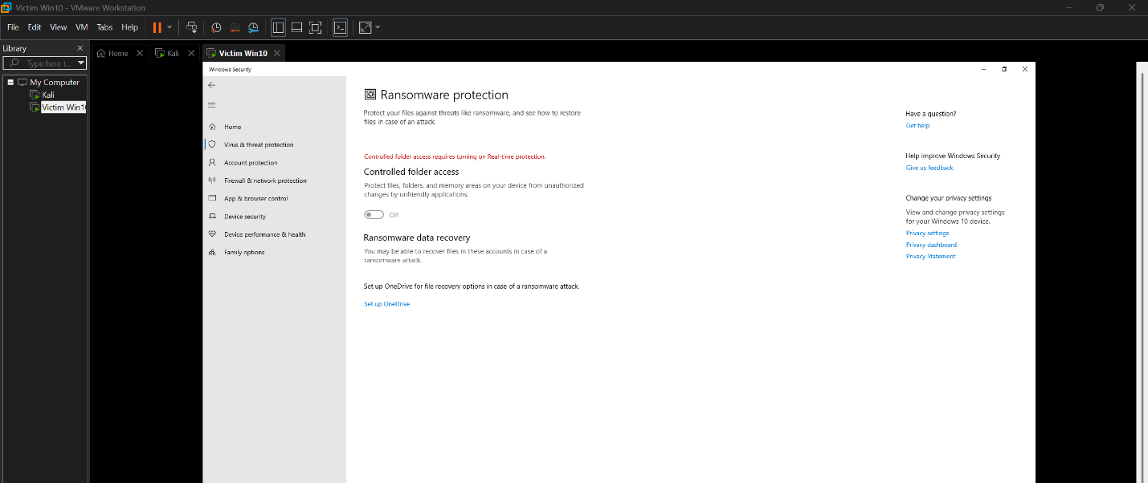
Controlled Folder Access disabled to permit memory acquisition and credential-theft tools.
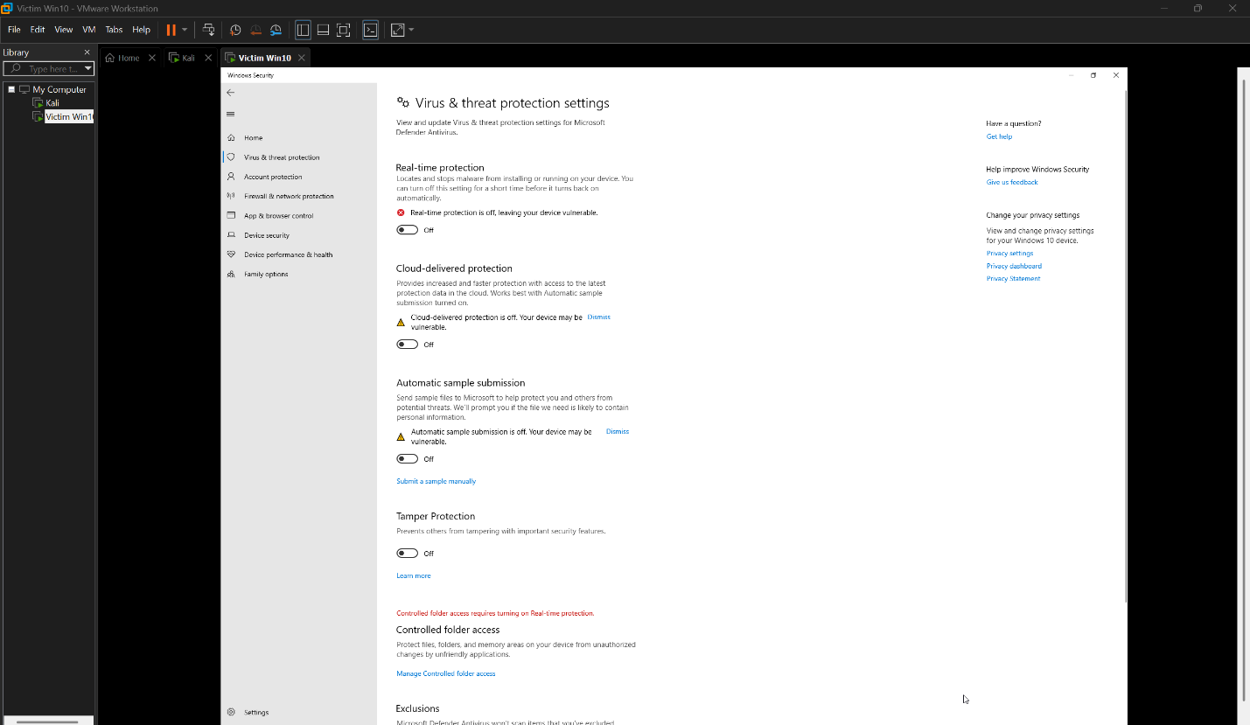
Windows Security panel showing disabled real-time protection and cloud-delivered protections.
5.2 Firewall Disablement for Controlled Testing
To ensure that payload delivery and memory acquisition tools operate without interference, the Windows Firewall was temporarily disabled.
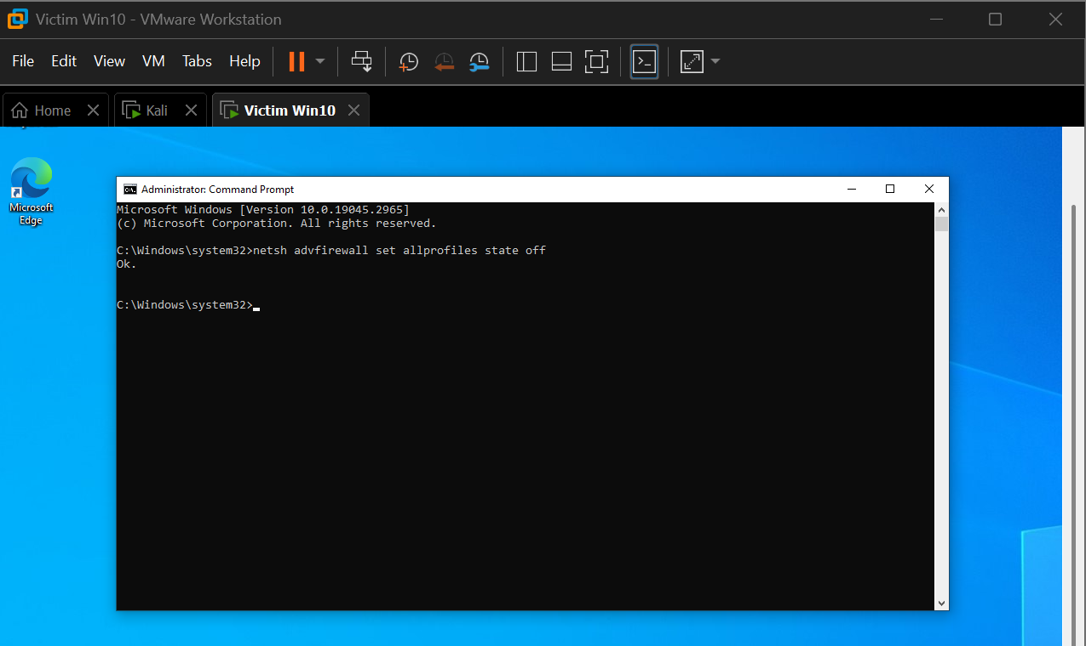
Firewall disabled on the Windows 10 VM to support controlled attack operations.
5.3 Creation of Tools Working Directory
A dedicated directory, C:\Tools, was created to store all Windows-based tools such as DumpIt, Sysinternals Suite, and extracted Mimikatz files.
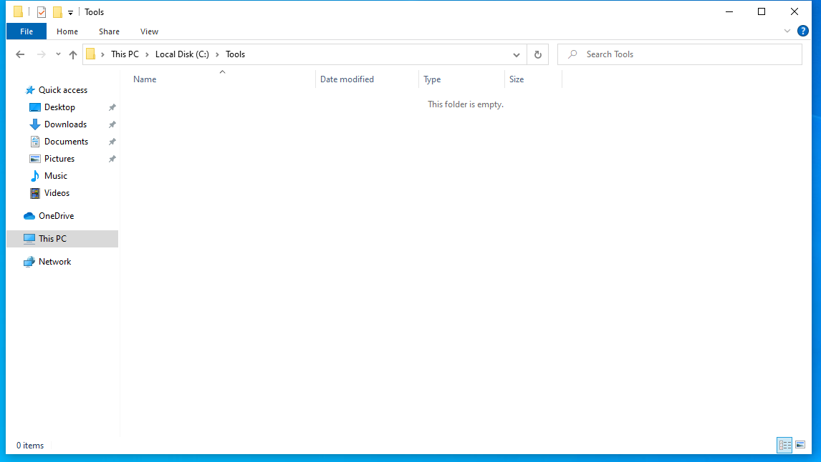
Clean C:\Tools directory prior to adding acquisition and attack utilities.
After tool extraction, the directory structure was verified.
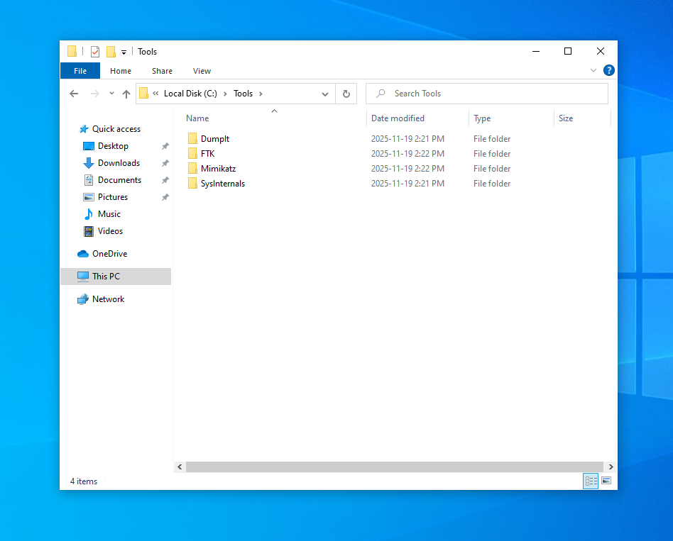
Organized C:\Tools directory containing DumpIt, Sysinternals, and Mimikatz.
5.4 Defender Exclusion Configuration
A Defender exclusion was added for the entire C:\Tools directory so that the files stored inside were not quarantined automatically.
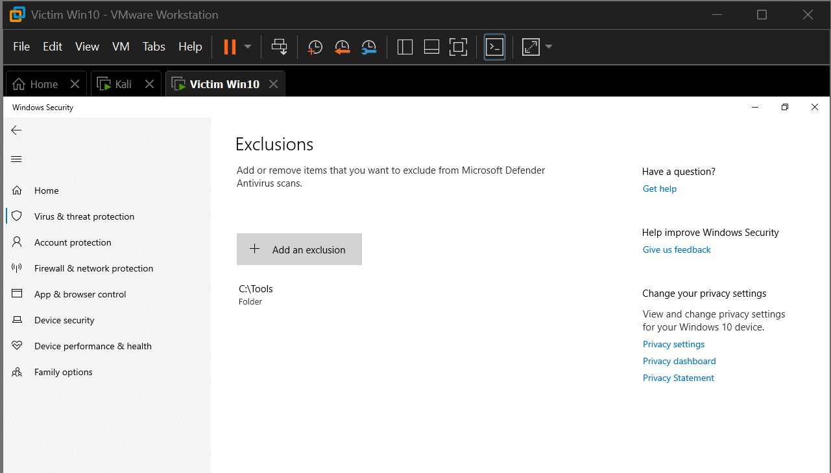
Windows Defender exclusion added for all tools stored in C:\Tools.

6. Kali Linux Attacker & Forensic Workstation Setup
6.1 System Update & Utility Installation
Kali Linux was updated using APT, and required utilities were installed, including curl, wget, netcat, git, unzip, and net-tools.
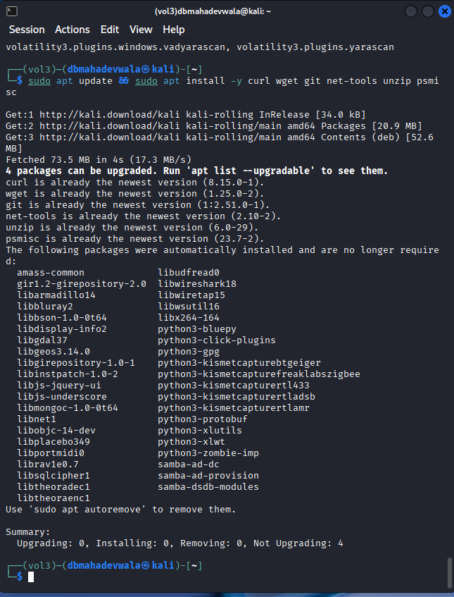
Installation of networking and system utilities on Kali Linux.
6.2 Directory Structure for Forensics and Attacks
A clean directory structure was created to separate forensic artefacts and attack payloads.
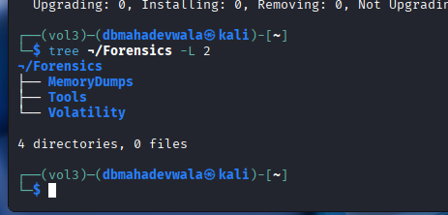
Directory layout inside Kali for Forensics and AttackTools.
6.3 Installing Volatility 3 in a Virtual Environment
A Python virtual environment was created specifically for Volatility 3 to avoid system-level conflicts. Volatility 3 installation was verified afterward.
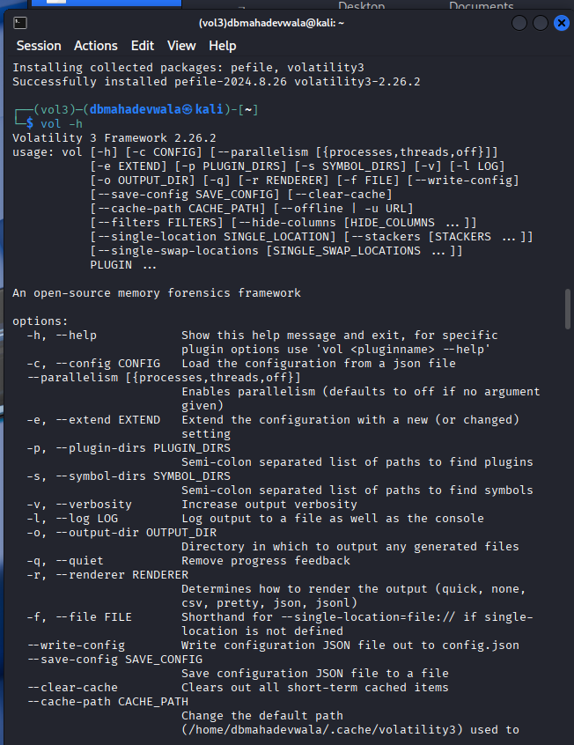
Successful installation of Volatility 3 on Kali Linux.
6.4 Networking Utility Verification
The proper functioning of key networking tools was confirmed.
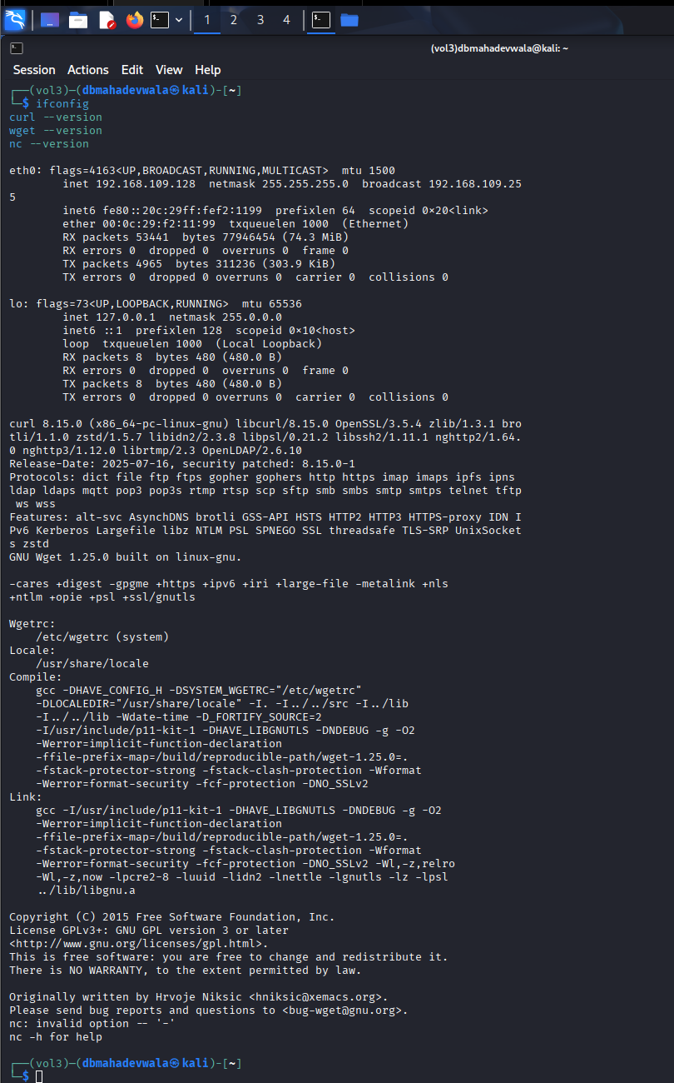
Version checks for curl, wget, ifconfig, and netcat.

7. Initial Network Verification (NAT Mode)
Both VMs were booted into NAT mode to ensure that they could obtain tools and updates. IP configuration and connectivity validation was performed in both directions.
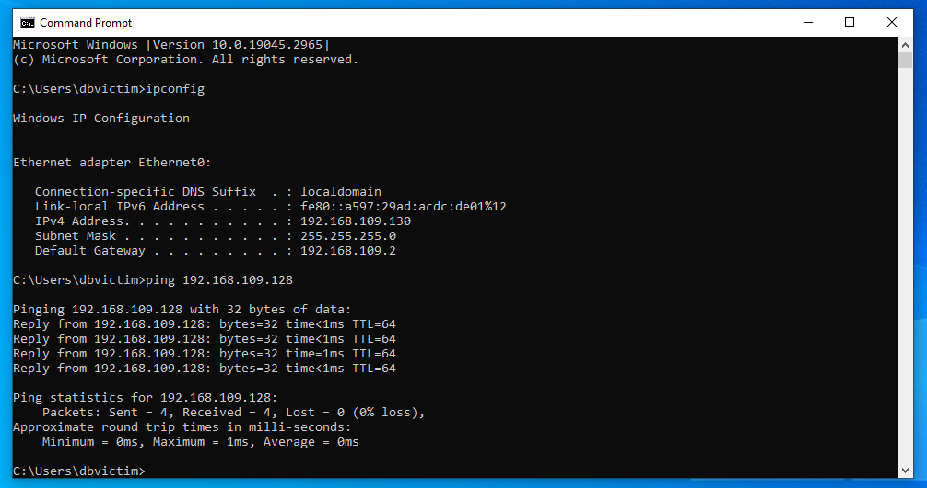
Windows correctly identifying its NAT IP and reaching Kali.
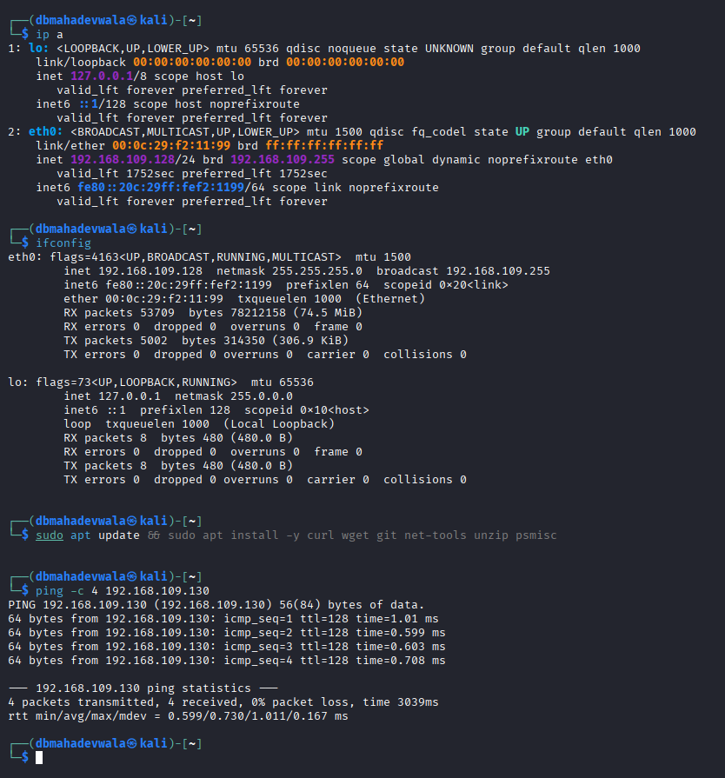
Kali Linux pinging the Windows NAT address successfully.

8. Switching to Host-Only Network & Isolation Validation
Once all tools were downloaded, both VMs were moved into VMware’s Host-Only network, severing their connection to the internet while maintaining communication between each other.
After switching network modes, both machines attempted to reach external IP addresses to confirm isolation.
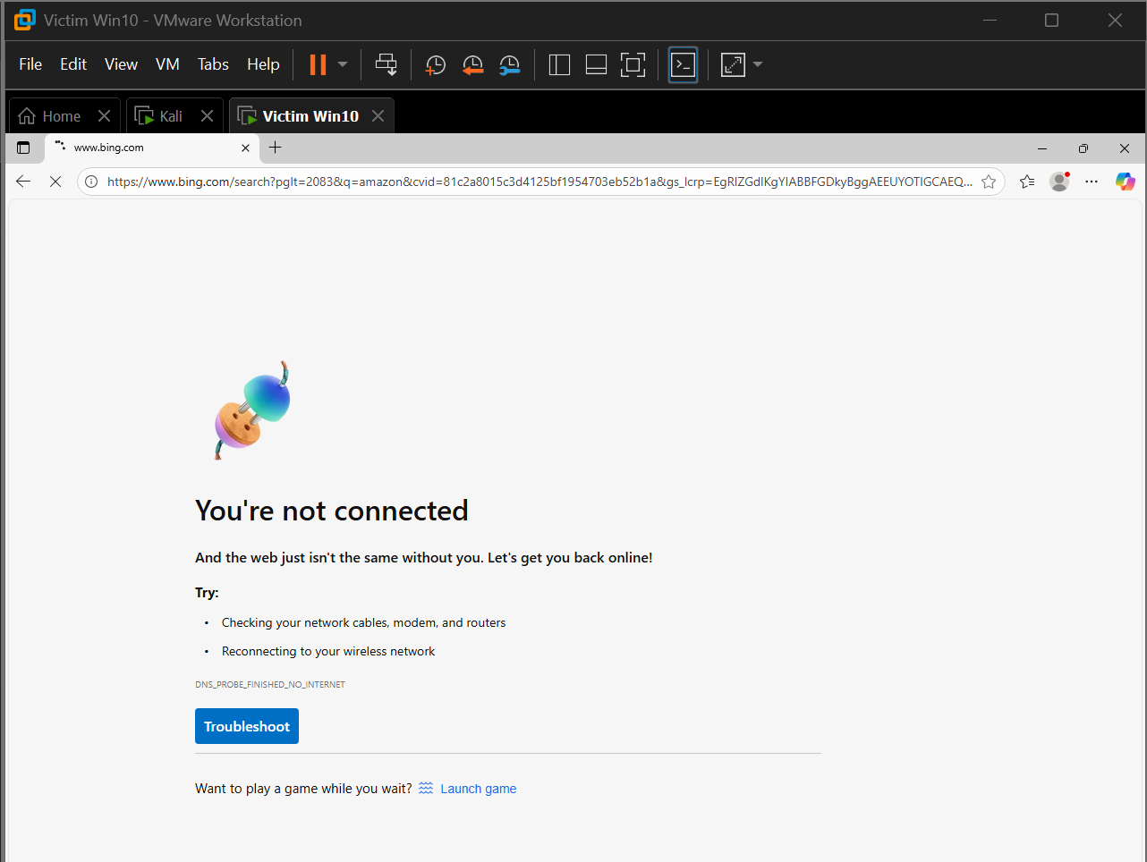
Internet access correctly disabled on Windows.
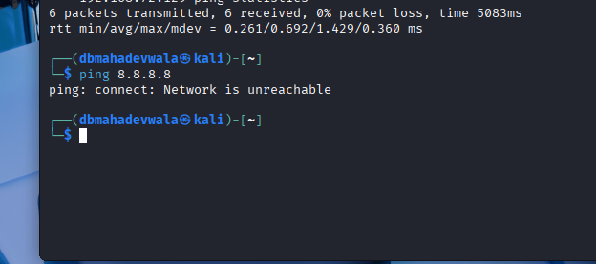
Kali’s inability to reach external IPs, confirming isolation.

9. Internal File Transfer Test (HTTP Server)
Kali Linux hosted an HTTP server inside the AttackTools directory using Python. The Windows VM accessed the server via a browser, confirming that payload transfer is functional under host-only conditions.
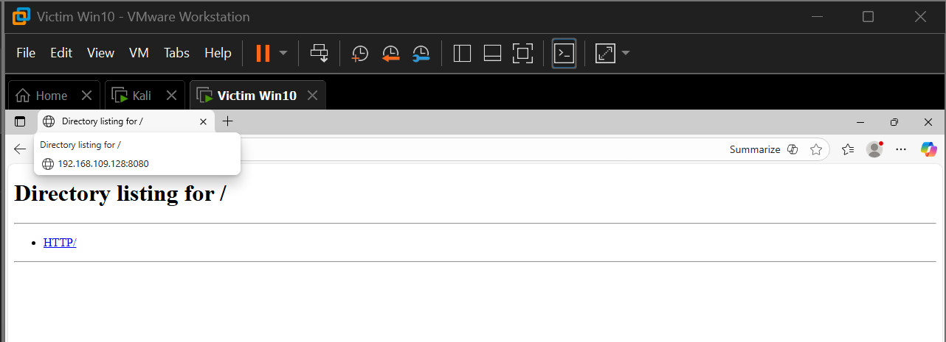
Successful file listing served from Kali and accessed from Windows.

10. Pre-Attack Snapshot Creation
Snapshots were taken on both Kali and Windows VMs to preserve the entire Phase 1 environment. These snapshots capture the exact system state before the attack simulation begins.
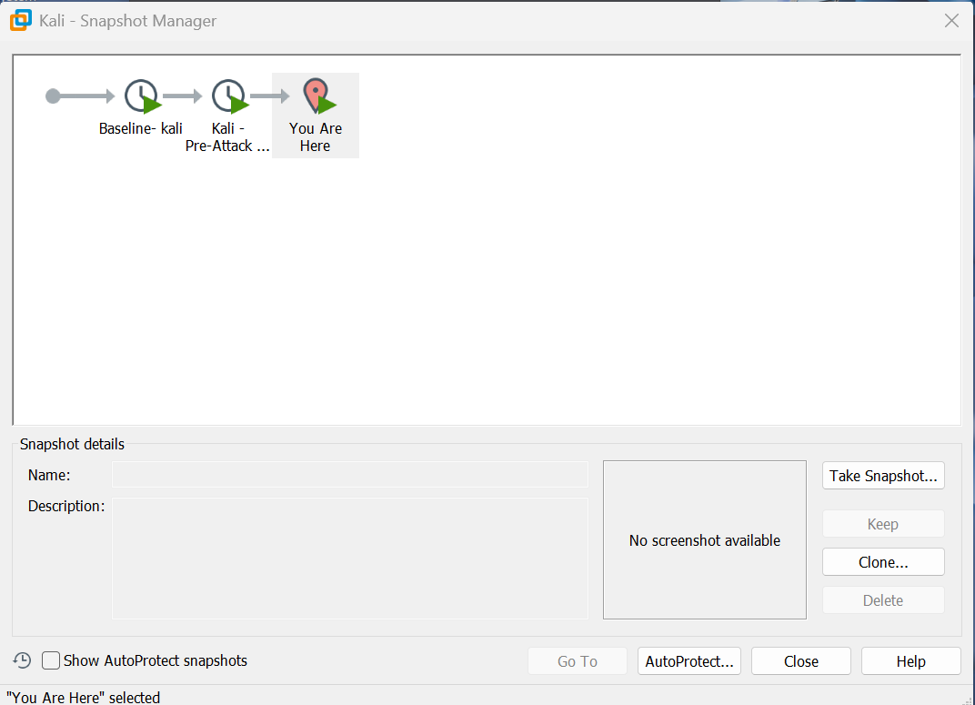
Pre-attack snapshot captured for Kali Linux.
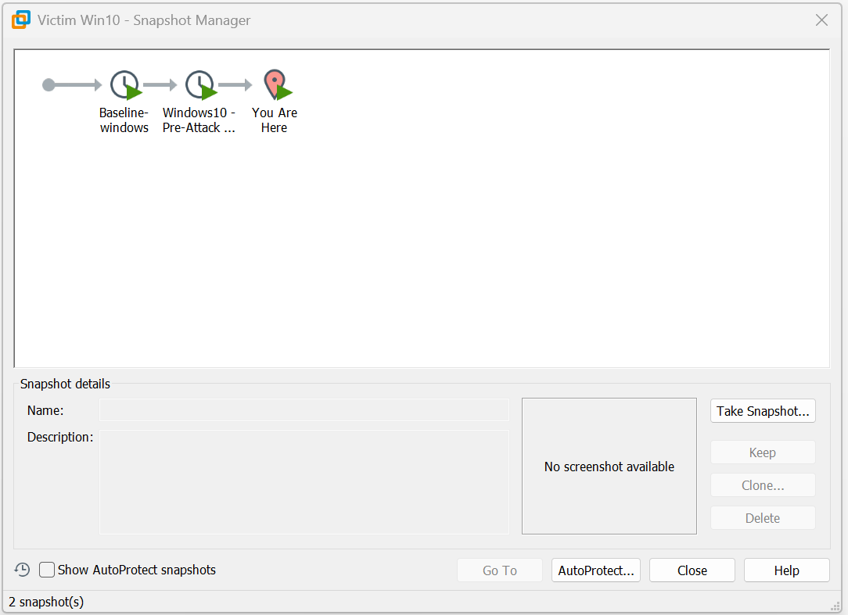
Windows 10 pre-attack snapshot stored in VMware.

